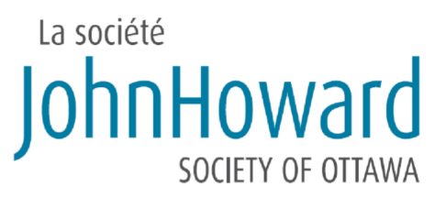
Client name:
DOB:
UCI #:
CASE PLAN
Based on the in-person assessment interview conducted with [client name] on [date(s)], the review of [client’s name]’s file and information received from collateral contacts, the CCMS case plan is as follows:
Example:
1. Mandatory residence at Résidence St. Anne at all times while on CCMS.
2. Mandatory referral to mental health supports: Injections, medication and clinical support at the Royal Ottawa Hospital (ROH).
3. Mandatory linkage to funding (ODSP/OW): Client needs funding from ODSP/OW, in order to pay for necessities of life and for mandatory health supports (injections and medication related to mental health).
4. Referral to physical health supports: Apply for OHIP card, if needed / possible. Medication and clinical supports, as required, in order to assist client in dealing with his physical health.
5. Referral to appropriate supports in order to help client achieve goal of completing his Ontario High-School diploma. This goal is contingent on the client’s status and its effect on his ability to study in Canada.
6. Connection to the Ottawa community and government resources in order to stabilize client while he remains on CCMS.
TIMELINE
Unless new information is obtained or further developments take place from now until [client name] is released to CCMS, JHS staff plan for case management to occur as per the following timeline:
Example:
The first step in the plan is to ensure that the client is connected to the ROH for both his injections and regular clinical follow-up with mental health professionals. Though all referrals are in place at this time, the client’s enrolment with CCMS is contingent on the ROH confirming that the client is: 1) on an active client list, 2) will be given regular appointment with an ROH mental health professional and 3) will receive monthly injections (past the first 2 months of injections pre-approved for funding).
The first 30 days of release will see [client name] confined to his residence at Résidence St. Anne. During this time, the main objectives will be for the client to get accustomed to his new surroundings, rules at St. Anne and the conditions of his release under ATD. Shortly after his arrival, JHS staff will accompany the client to the ODSP / OW offices in order to complete necessary paperwork for short and long-term funding (this cannot be completed while the client remains in custody). Should the client be ineligible for funding, JHS will request that he be removed from CCMS as it is imperative that he have funding in place to pay for his injections (ODSP).
Once the client has completed his first 30 days of confinement and is properly connected to the ROH and funding (ODSP/OW), case planning will focus on ensuring that the client’s physical health needs are met. An application for OHIP will be made, if necessary. Simultaneously, the client and his CCMS Case Manager will focus on linkages to education programs (if the client remains able to study in Canada) as well as various community organizations and services available in Ottawa, in order to stabilize the client until he no longer requires CCMS and/or case closure.

Case plan last updated on: [date]

